Dashboard Report

**Question 1: Identify the rating distribution in the ShopNest dataset, showcasing ratings categorized as Excellent, Very Good, Good, Bad, and Very Bad, along with corresponding orders.**

**Visualization**:

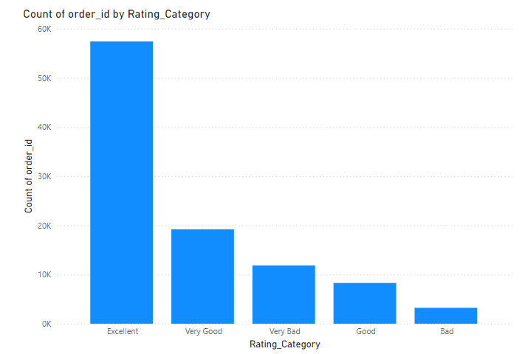

**Detailed Explanation**:  
In this visual, we categorize the ratings given by customers after their orders into five distinct groups: Excellent, Very Good, Good, Bad, and Very Bad. The purpose of this visual is to understand customer satisfaction across different orders. From the visual, we can infer that:

* **Excellent and Very Good ratings** dominate the dataset, accounting for the largest share of orders. This suggests that most customers are satisfied with their orders and the service provided by ShopNest.
* **Good ratings** also have a significant proportion, which indicates that while customers are generally satisfied, there may be room for improvement in certain areas.
* **Bad and Very Bad ratings** are minimal in comparison, but these are critical data points for the business to focus on. Even though the percentage of negative reviews is low, these reflect specific cases where the customer experience did not meet expectations.

By focusing on improving the service for orders that received Bad and Very Bad ratings, ShopNest can enhance overall customer satisfaction and reduce the likelihood of losing future business.

**Question 2: What are the top 10 and bottom 18 most popular product categories in the ShopNest dataset? Please list them based on the number of orders.**

**Visualization**:  
  
**Top 10 Categories   
  
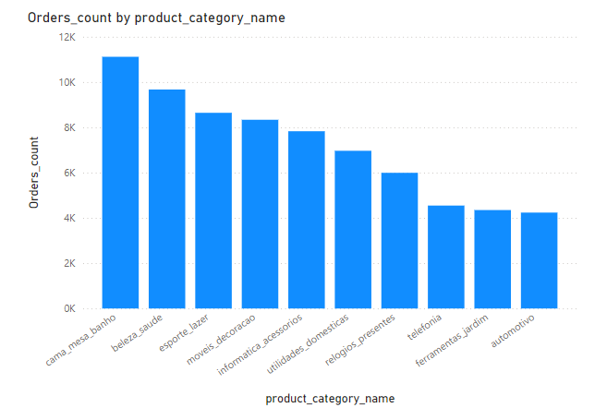  
  
Bottom 18 Categories  
  
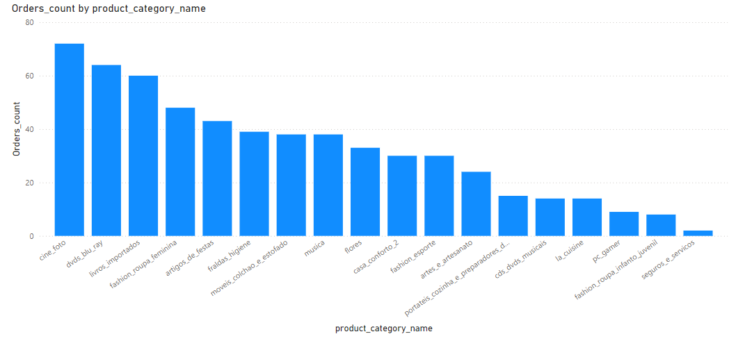  
Detailed Explanation**:  
This visual ranks the product categories from the ShopNest dataset based on the total number of orders placed for each category. The chart highlights two distinct groups:

* **Top 10 Categories**: These categories, such as electronics, home appliances, and clothing, account for the highest number of orders. These categories likely drive most of ShopNest's revenue, as they are the most frequently ordered. It’s essential for ShopNest to maintain a sufficient inventory, provide competitive pricing, and run targeted marketing campaigns for these high-demand categories to maximize revenue.
* **Bottom 18 Categories**: These categories receive the least number of orders. They might represent niche products or items with limited appeal. For these categories, the business might consider whether to continue offering them or look for opportunities to promote them more effectively to increase their popularity.

By analyzing this distribution, ShopNest can prioritize inventory and marketing efforts on the most popular categories while exploring ways to increase demand for the less popular ones.

**Question 3: List the total number of active sellers by yearly and monthly.**

**Visualization**:  
  
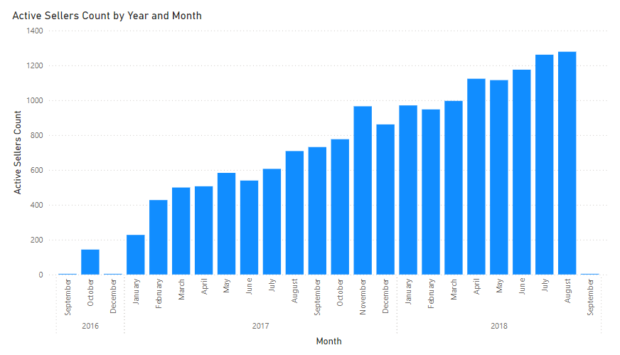

**Detailed Explanation**:  
The goal of this visual is to show how the number of active sellers on the ShopNest platform changes over time. The chart tracks the data both **yearly** and **monthly**:

* **Yearly Trends**: Over time, we can see that the number of active sellers has generally increased, reflecting growth in the platform’s seller base. This could be due to the expansion of ShopNest's market reach, improved seller support, or competitive advantages that attract more sellers. The steady increase is a positive indicator for the business.
* **Monthly Trends**: The monthly view reveals more granular patterns, with noticeable peaks during specific months, potentially correlating with key shopping events like Black Friday, holiday seasons, or sales promotions. These spikes suggest periods when sellers are particularly active, possibly stocking up on inventory to meet expected demand. Conversely, some months may show dips, indicating periods of lower activity, possibly in off-peak shopping times.

Understanding these trends helps the business plan ahead for peak seasons and manage seller engagement during slower months.

**Question 4: Which payment methods are most commonly used by ShopNest customers?**

**Visualization**:  
  
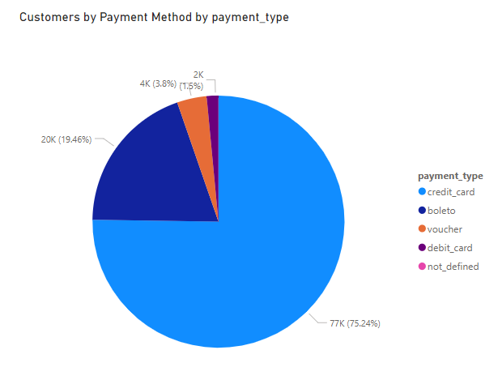

**Detailed Explanation**:  
This visual breaks down the payment methods that ShopNest customers use when placing their orders. The chart highlights the following key insights:

* **Dominance of Credit Cards**: A significant portion of payments is made using credit cards. This suggests that most customers prefer this payment method, possibly due to the convenience or rewards programs associated with credit card usage. ShopNest might consider partnering with credit card companies to offer additional incentives, such as cashback or discounts.
* **Other Popular Payment Methods**: The next most popular methods are debit cards and digital wallets, though they are used less frequently than credit cards. Digital wallets represent a growing trend, and ShopNest might consider offering promotions or improving the integration of wallet services to capture more of this market.
* **Least Used Methods**: Methods like bank transfers or other payment methods account for a small percentage of transactions, indicating that customers may find them inconvenient or less favorable.

By understanding these preferences, ShopNest can tailor its payment options and promotional campaigns to align with customer behavior and potentially increase conversion rates by offering preferred payment methods.

**Question 5: Identify the product category-wise profit margin using the formula.**

**Visualization**:  
  
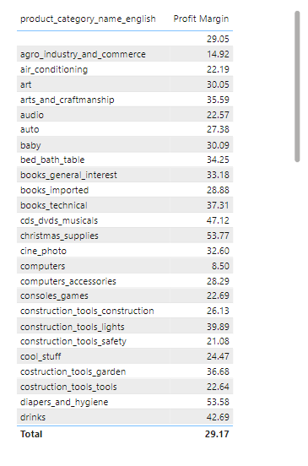

**Detailed Explanation**:  
In this visual, we calculate the **profit margin** for each product category using the formula:

Profit Margin = (Payment Value – Price + Freight Value ) / Payment Value × 100

The goal is to understand which product categories generate the highest profit margins and which ones generate lower margins. The visual reveals that:

* **High-Margin Categories**: Categories such as electronics and appliances tend to have higher profit margins. This may be due to higher pricing and value-added services (such as extended warranties or shipping fees) contributing to profitability. These categories are key drivers of profitability for ShopNest, and the business should focus on maintaining a competitive advantage here.
* **Low-Margin Categories**: Categories like clothing or accessories may have lower profit margins due to lower pricing or higher competition. While these items may still generate significant sales volume, ShopNest might explore ways to improve margins through cost-cutting measures or by offering bundled services.

By analyzing the profit margins, ShopNest can optimize its pricing strategies, focus on high-margin products, and make informed decisions about inventory management.

**Question 6: Determine the monthly payments made by customers using credit cards.**

**Visualization**:  
  
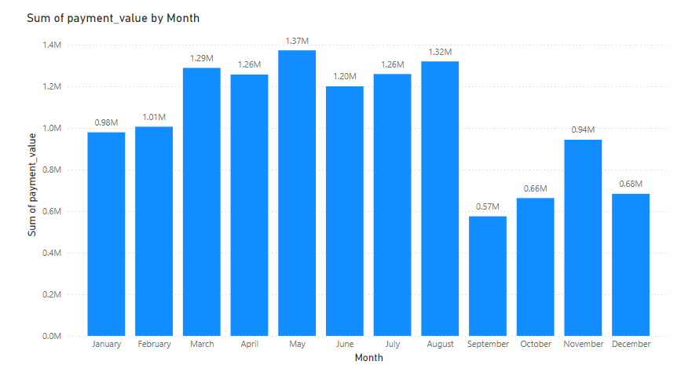

**Detailed Explanation**:  
This visual tracks the monthly payments made by customers using credit cards. The clustered column chart allows us to observe fluctuations in credit card payments across different months. From the data, we can deduce the following:

* **Seasonal Peaks**: Payments tend to peak during specific months, such as November and December, which coincide with holiday shopping periods. This surge is likely driven by increased customer spending during festive seasons and special promotions.
* **Off-Peak Months**: Conversely, months like February and March may show lower transaction volumes, suggesting a post-holiday slowdown. Identifying these off-peak periods helps ShopNest prepare for potential dips in revenue and adjust marketing efforts accordingly.

Understanding these payment trends enables ShopNest to optimize its financial planning, offer credit card-specific promotions, and better cater to customer preferences throughout the year.

**Question 7: Identify sellers categorized by city, excluding cities starting with the letters S and B.**

**Visualization**:  
  
**Sellers by City (Excluding Cities Starting with S and B)**  
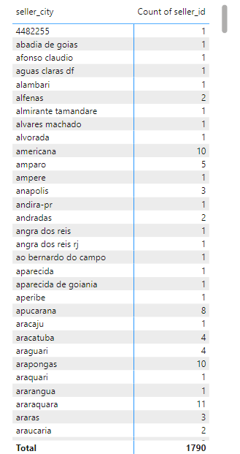

**Detailed Explanation**:  
This visual provides an overview of sellers distributed across various cities, with cities starting with the letters "S" and "B" excluded from the dataset. Key insights include:

* **Top Cities by Seller Count**: The visual highlights cities like Curitiba, Rio de Janeiro, and Ribeirao Preto as having the highest number of sellers. This indicates that these cities are major hubs for ShopNest's seller base, likely due to their large population sizes and strong e-commerce ecosystems.
* **Excluded Cities**: By excluding cities that start with "S" and "B" (e.g., San Francisco, Boston), we focus on identifying seller patterns in other locations. This exclusion allows the business to explore opportunities for growth in non-major cities.

This insight is useful for regional marketing efforts, expanding seller networks, and understanding how geographic factors influence seller engagement.

**Question 8: Create a dynamic visual that compares the number of delayed orders to the number of orders received earlier for each month. Utilize the drill-through feature to provide a detailed analysis of late and on-time deliveries.**

**Visualization**:  
  
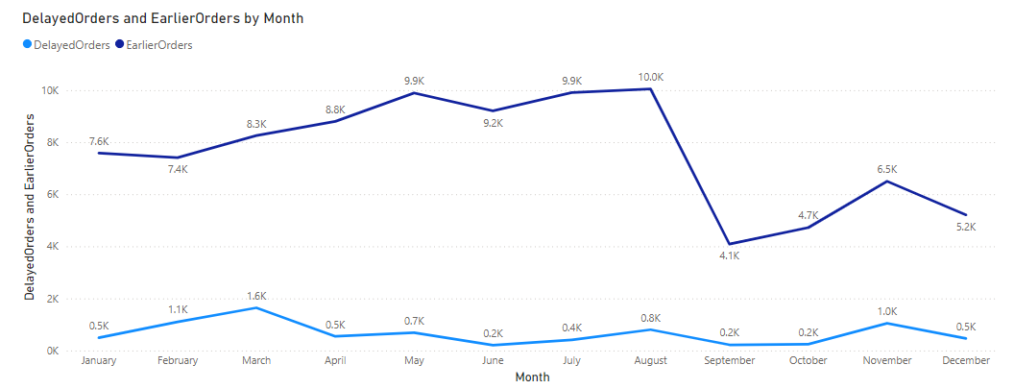

**Detailed Explanation**:  
In this visual, we are comparing the **number of delayed orders** against the **number of orders received earlier or on-time** on a month-by-month basis. This visual aims to provide a high-level overview of ShopNest’s delivery performance, helping to identify months where delays are frequent and months where deliveries are mostly timely.

* **Delayed Orders**: These are orders that were delivered after the expected or promised delivery date. From the visual, we can observe certain months, such as **November and December**, tend to have higher numbers of delayed deliveries, likely due to the holiday shopping season, when order volumes peak. Seasonal surges put pressure on the supply chain, resulting in more delayed shipments.
* **On-Time or Early Deliveries**: These are orders that were delivered on time or even earlier than expected. During off-peak months, such as **March and April**, there are generally fewer orders, which allows logistics to function more efficiently, resulting in better delivery performance.

The purpose of this chart is to give a bird’s-eye view of delivery efficiency across the year. By understanding which months face delays more frequently, ShopNest can better plan for these periods by optimizing resources, managing stock more efficiently, and providing clear communication to customers about expected delivery times.

**Drill-Through Feature Explanation:**

The **drill-through feature** allows for a more detailed breakdown of the visual data. By utilizing drill-through, a user can click on a specific month in the visual and be taken to a detailed report that provides insights into the exact reasons for late or on-time deliveries for that month. This feature helps provide deeper analysis and actionable insights.  
  
**Visualization**:  
  
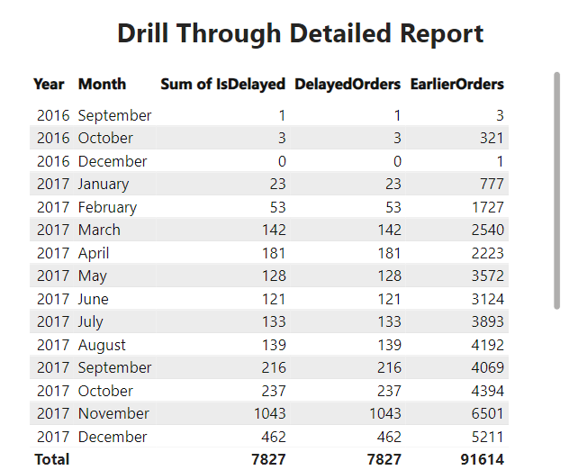

**Steps to Use the Drill-Through Feature:**

1. **Interactive Navigation**: In the dynamic visual, users can right-click on any specific data point (e.g., a bar or line representing a month) and select the drill-through option. This action will take the user to a detailed page dedicated to that month’s deliveries.
2. **Detailed Breakdown**: On the drill-through page, users will find more granular information, such as:
   * The **specific number of delayed orders**, broken down by **product category**, **shipping provider**, and **location**.
   * The **average delay time** for each order, helping to identify how late the deliveries were.
   * A comparison between the **on-time rate for different products** or **regions** during that month. For example, certain regions or delivery partners may consistently cause delays, while others perform better.
3. **Late vs. On-Time Delivery Analysis**:
   * Users can explore factors contributing to delays, such as **weather conditions**, **order volume surges**, or **logistics issues** (e.g., out-of-stock items, supply chain disruptions).
   * The drill-through analysis helps pinpoint specific months with higher-than-average delays, allowing ShopNest to investigate root causes and strategize accordingly. For instance, if December has a high delay rate due to supply chain issues, ShopNest might plan for early stocking and partner with reliable couriers during that time.
4. **Actionable Insights**:
   * The drill-through analysis can show patterns in late deliveries across months, helping to determine if **certain carriers** or **product categories** consistently experience delays.
   * ShopNest can then decide whether to optimize vendor relationships, enhance inventory forecasting, or implement customer notifications about expected delays during peak periods.

**Key Benefits of the Drill-Through Feature:**

* **Deeper Analysis**: Users can move beyond high-level monthly trends and explore specifics such as delivery times for individual sellers, regions, or product types. This helps to isolate recurring issues and take corrective actions.
* **Actionable Insights**: ShopNest can use this data to **improve delivery times** during peak seasons, negotiate better terms with delivery providers, and allocate resources more effectively.
* **Improved Customer Experience**: By identifying patterns in delays and implementing proactive measures (such as better stock management and partnering with faster carriers), ShopNest can enhance customer satisfaction and reduce negative feedback caused by delayed deliveries.